Thomas Nattestad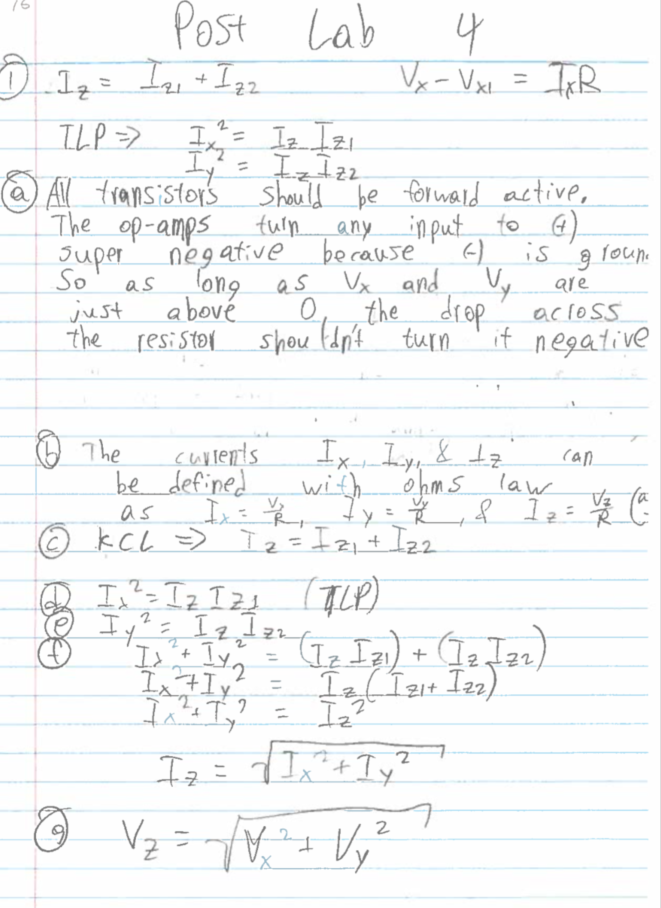

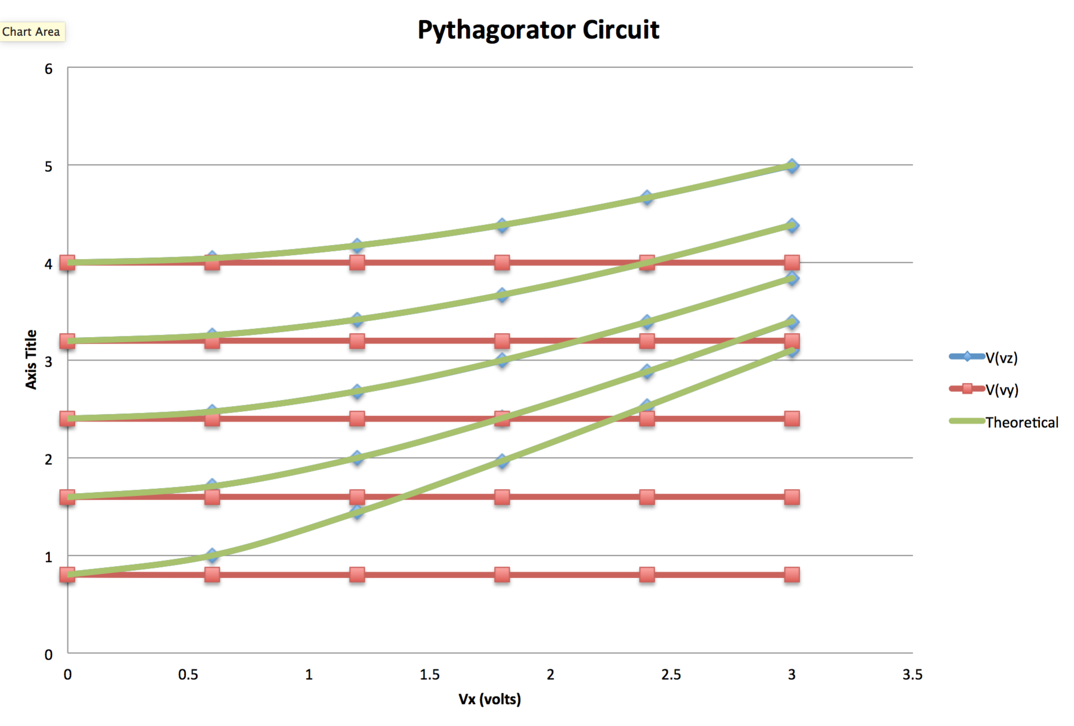

The circuit has exactly the behavior we expected as can be seen from the match on Vz and the theoretical fit of Vz